Cannot Create New Domain Message Seen In 1920: "There Are User(S) Online, Can Not Be Configured"

**Labels: OfficedConnect, HPE Comware Switch**

**Requirement:**

Background:

1920 is a Comware 5 version switch model.

Currently only local-user authentication is being used to log into Office Connect 1920 (JG922A).

Instead of local authentication, TACACS server should authenticate the user who wants to log into the switch.

We already have HWTACAS(Huwaei TACACS) scheme in place:

    [1920] hwtacacs scheme hwtac  
    [1920-hwtacacs-hwtac] primary authentication 10.1.1.1   
    [1920-hwtacacs-hwtac] primary authorization 10.1.1.1  
    [1920-hwtacacs-hwtac] primary accounting 10.1.1.1  
    [1920-hwtacacs-hwtac] key authentication simple Passw0rd@123   
    [1920-hwtacacs-hwtac] key authorization simple Passw0rd@123   
    [1920-hwtacacs-hwtac] key accounting simple Passw0rd@123  
    [1920-hwtacacs-hwtac] user-name-format without-domain  
    [1920-hwtacacs-hwtac] nas-ip 10.1.1.100  
    [1920-hwtacacs-hwtac] quit

Now we need to bind this scheme with a domain.

In our case it is *system, system*is default domain in Comware devices.

**If user is currently logged under *system* domain and wants to bind the *system*domain with hwtacacs scheme, user will not be able to that.**

[1920] domain *system*

[1920-isp-system]authentication default hwtacas-scheme hwtac local

***There are user(s) online, cannot be configured***  
**<< The above message would be visible soon after trying to tie default domain with hwtac scheme >>**

Note: Above message is not observed in Comware7 and most of the Comware5 devices.

But if you happen to face such issue, you can follow the following steps:

**Solution:**

Option 1 (when system domain need to be used):

* Create a new domain as temporary domain and set all the authentication and authorization scheme to local.
* Then log off all the users and login to this new domain (by adding @domain-name in your username to login).
* Once login, you are in that temp domain, you can make change on the default domain as there is no more user login to it.

Option 2 (when non-system domain need to be used):

* Create a new domain and link HWTACACS scheme to it. Then set it to default domain and use it to authentication the user via TACACS

We will walk through Option 1 here.

**Configuration:**

* Start by seeing the current user.

We can see that the user is under *system* domain.



Only one user is online using VTY line 0.

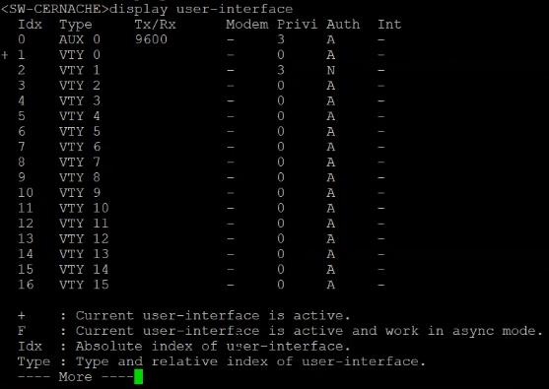

* Create the test domain, no need to configure anything under this domain because by default authentication/authorization/accounting will be all local.

To create a domain, use:

[1920]*domain gbimbo*

Also, we could see that by default a domain uses local AAA schemes.

It's a good practice to check the domain specifics, use *display domain.*

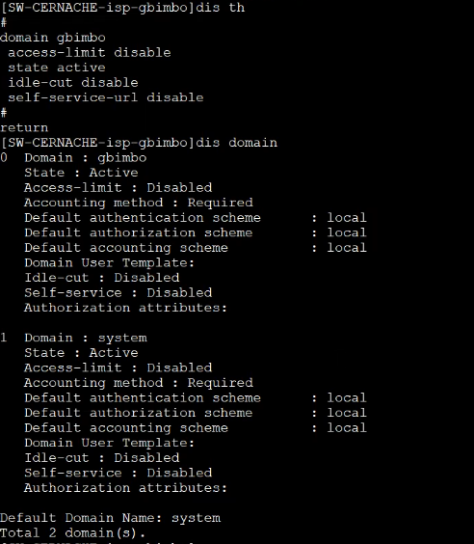

Note: At this point default domain is still *system.*

* Once the domain is created, login into the switch using username@domain.

Here domain name is gbimbo

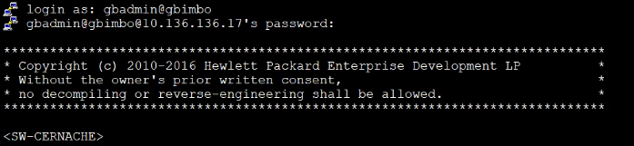

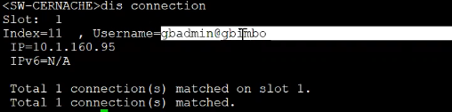

* Bind HWTACAS scheme with system domain.

Configure as below.

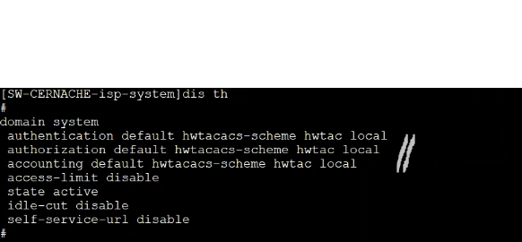

​

* Next, login with system domain.

User 182502 got TACACS authenticated.

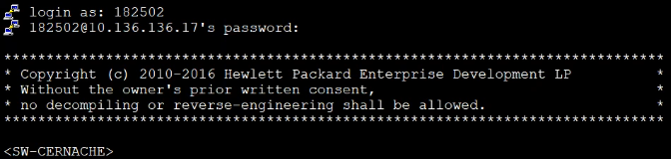

Active user is using default domain using VTY line 3, notice the + sign.

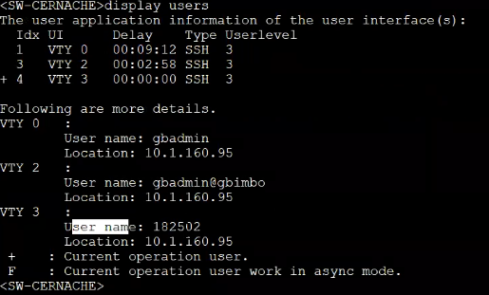

* Finally remove the test domain gbimbo which we created before to facilitate configuration under system domain.

Before, deleting test domain, close any existing session logged with the test domain gbimbo.

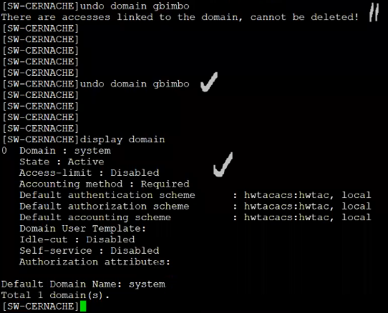

**Verification:**

For verification use:

*display users*

*display connection*

*display domain*

Tags: OfficedConnect, HPE Comware Switch, 1910-8-poe-jg537a_5.20.r1118, 1920, #officeconnect, comware 5, #domain, hwtacacs, #tacacs